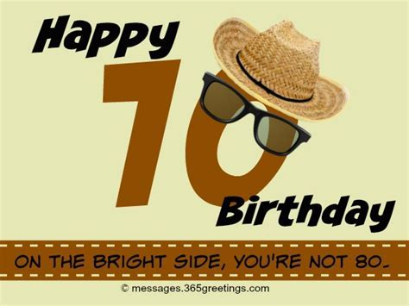

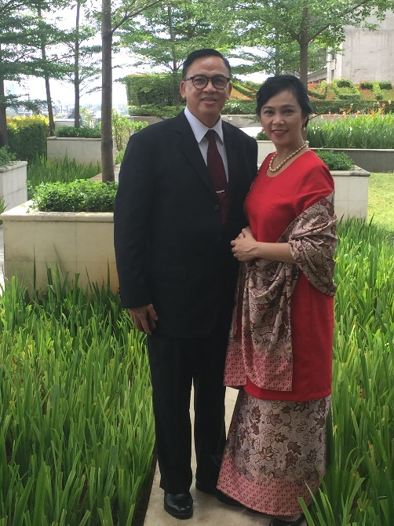

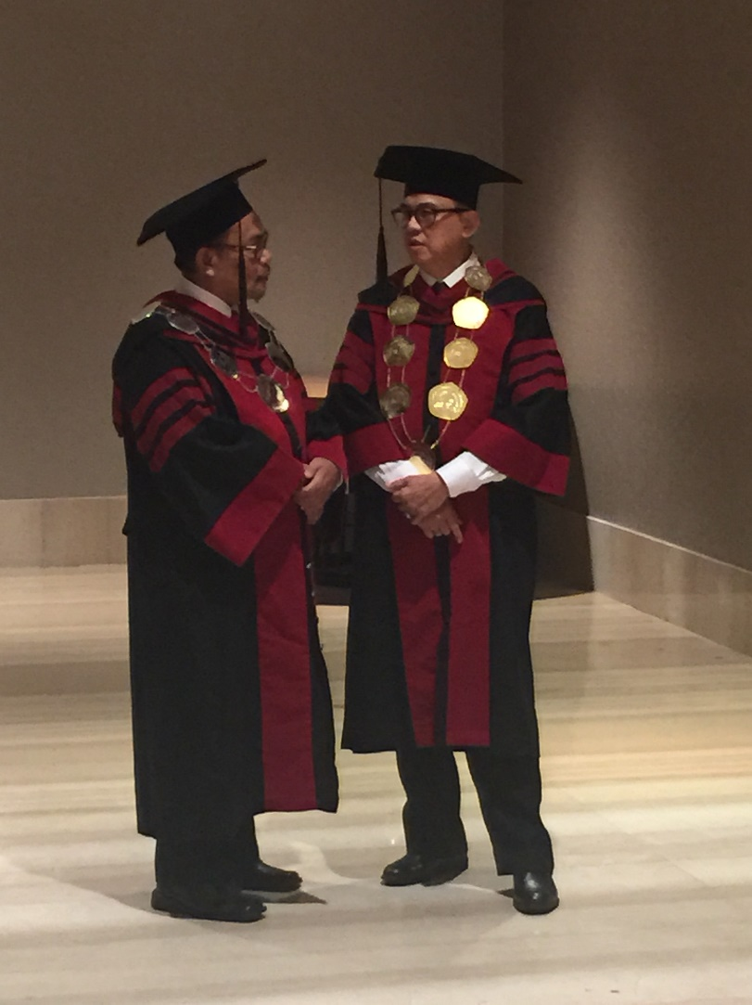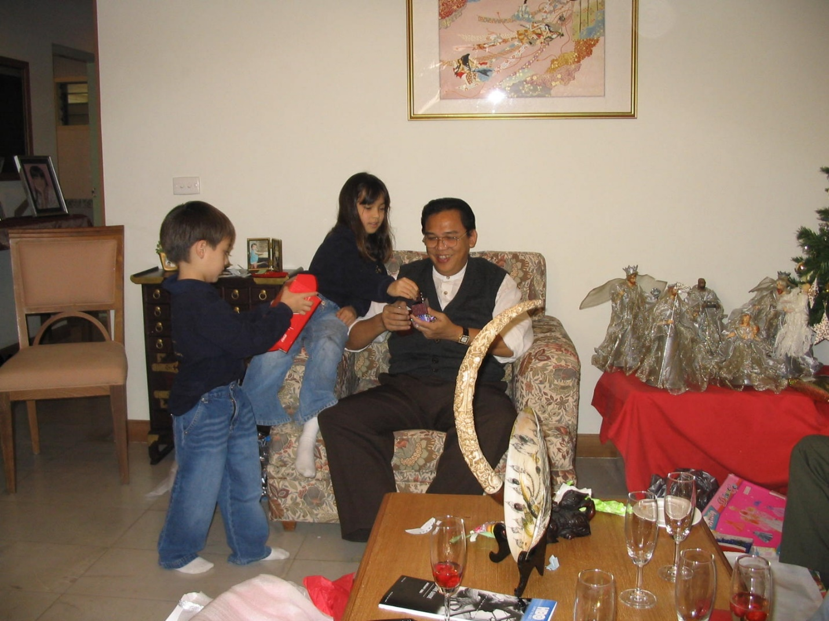Dear Wisnu, congratulation for being18 with 52 years of experience!

Vietnam – Dec 2003

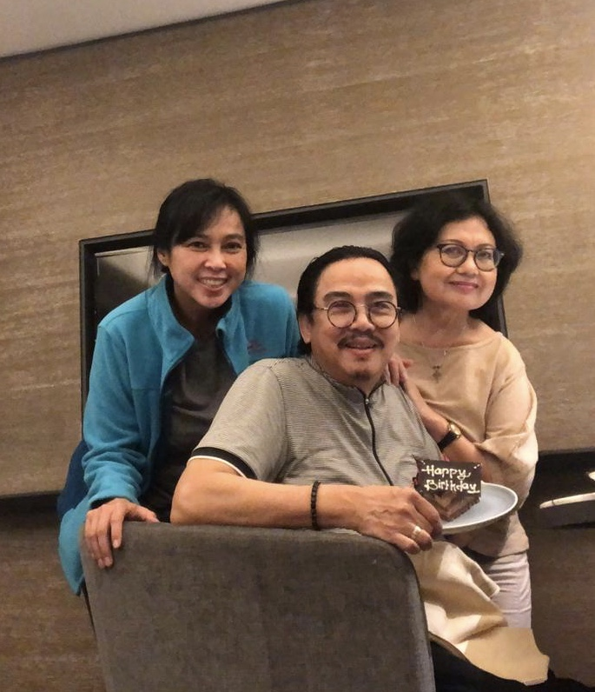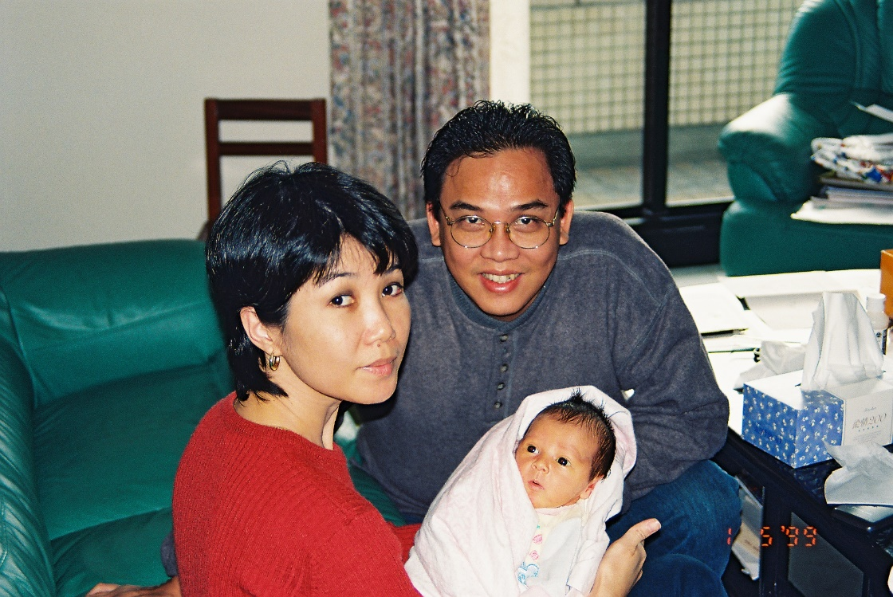 Jakarta – Dec 2016 Jakarta – Dec 2016

Jakarta – Sept 2019

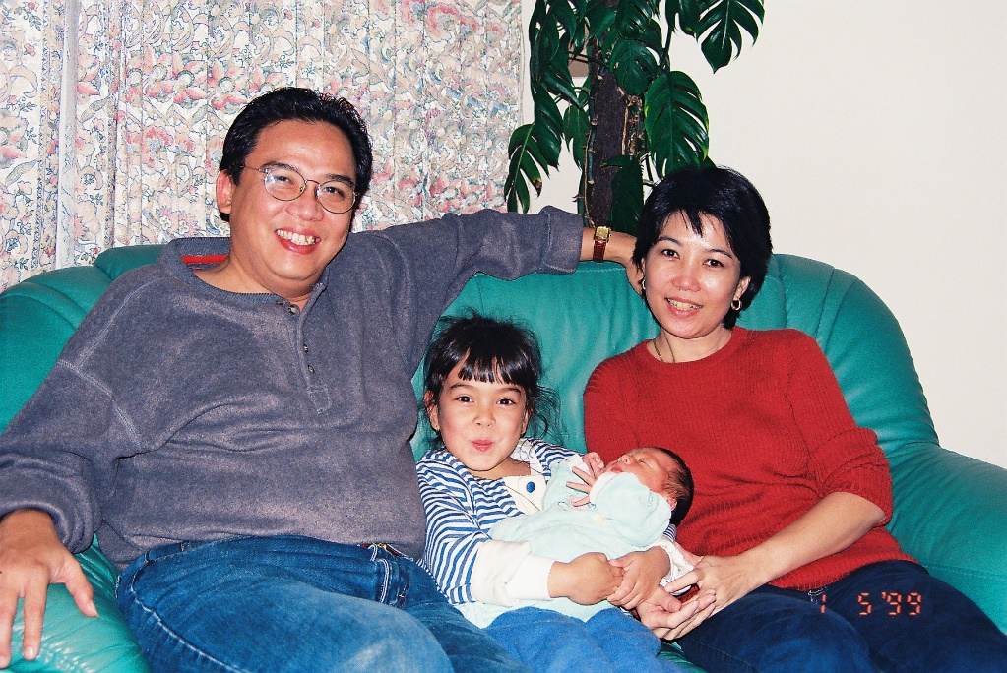Taipei – Jan 1999 Taipei – Jan 1999

My dad is special and unique in every sense. He touched and continues to touch people’s lives in various different ways. You may agreed or disagreed with him, but the fact is that he shines and stands out among the crowd.

Reflecting back all past years, I realized that some of my principles and values in Life were instilled and taught by him. I would like to share few of those principles and values that guides my life everyday :

1. Heaven and blessing are open when you first **be the blessing to others**.
2. See the **positive in people**, for there are always two sides in each person.
3. It is better to be in position to give than to receive, and be grateful.
4. **Think carefully** and **decide** about what you want, **be bold** and go get it.
5. You are never too old to learn and start something.

Thank you Dad, for teaching me those values and principles, and to teach me many other things, through your words, actions, and experiences.

Have a great 70th Birthday !!! May God continues to bless you with many more years of good health and happiness. Love you !!!

Puri Swastika Gusti Krisna Dewi